HN
(ORIGINALLY PUBLISHED 1/20/26 4:39 PM EST)
America is being destabilized and destroyed by design.
Since 1954, the Democrat Party and seditious, treasonous Republicans in name only, have been engaged in a quiet war against The United States, working at the behest of their clandestine CFR/UN/World Economic Forum partners, in a globalized effort to merge the United States into a one world totalitarian socialist government.
This global elite alliance is known as the ROUND TABLE GROUPS.
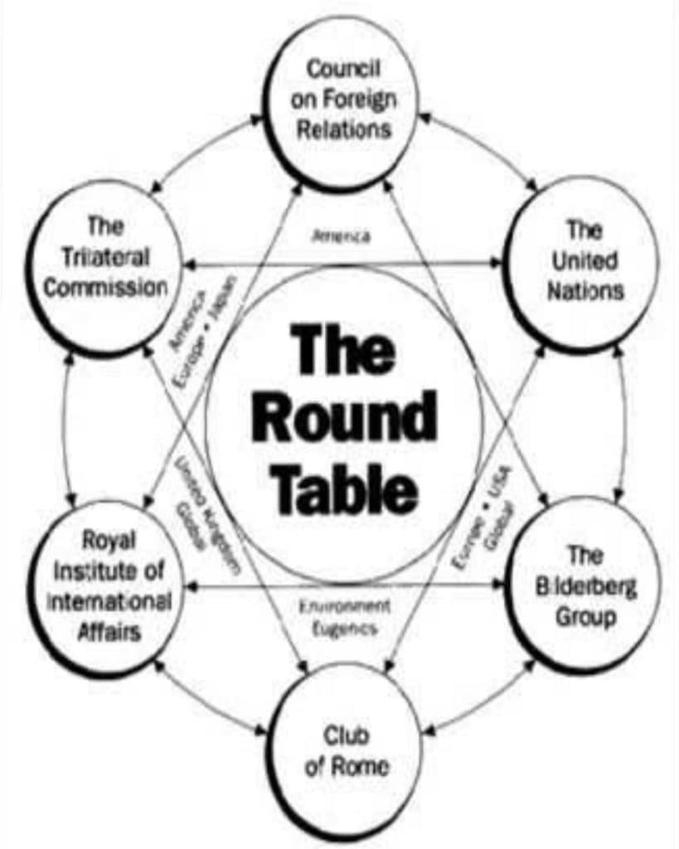
The genesis of this agenda goes back even further, to the Act of 1871, which created the corporation of THE UNITED STATES OF AMERICA.
At the end of the Civil war congress reconvened and passed what was called the United States Reorganization act of 1871, also known as the Act of 1871, to provide a municipal government for the District of Columbia.
However, this government was different; it was structured as a foreign owned CORPORATION and called the UNITED STATES! It even adopted the Republic constitution but changed only one word. They changed the word Constitution FOR the United States, to the Constitution OF the United States.
Therefore this change made the constitution a possession of the government corporation and NOT the possession of the people. The only power this government had was to govern over matters of COMMERCE within the District of Columbia.
What we call STATE OF (YOUR STATE), is actually a SUB corporation of the UNITED STATES CORPORATION engaged in matters of commerce.
This STATE is not to be confused with the Union State of (your State), which is part of the original pre-Civil war Republic. Therefore, the UNITED STATES (Corp) is foreign to the Union States as its geographic boundaries are restricted to the land area of the District of Columbia. This distinction has been recognized in numerous court cases before the U.S. Supreme court.
Don't take my word for it, read Cooperative Federalism by Gerald Brown, Ed.D.
The fact of the matter is, almost ALL government entities are now commercial contracting corporations of some type, complete with a Tax Identification Number (TIN), and a full Dunn and Bradstreet credit report!
Don't believe it? Check out the DUNN AND BRADSTREET credit report for the SUPREME COURT! SUPREME COURT D & B CREDIT REPORT
Download a complete copy of the Act of 1871 as printed by the UNITED STATES printing office and read it for yourself. The Birth of the Second UNITED STATES- The Act of 1871
https://www.youtube.com/watch?v=lVsMUpPgdT0
Here is the modern day timeline:
In 2000, the Democrats and their Round Table Group masters partnered with their not so covert partners in China to begin UNRESTRICTIVE WARFARE against America. That year China was accepted into the elite globalist controlled World Trade Organization. Subsequently, tainted made in China products like sheet rock, pharmaceuticals, dog food and baby food proliferated U.S. markets.
Next, indoctrination propaganda was foisted upon the minds American students via the communist Teachers Union and at Universities in the U.S.
Read The Deliberate Dumbing Down of America by Charlotte Iserbyt
Today, in 2026, we can clearly see the how much damage China's influence has done to harm, dumb down and indoctrinate the minds of millions of American college students, haven't we?
Many woke college students today can barely read and write, or perform simple mathematics. They have no social skills, or interview skills for landing a job, avoid face to face conversations unless they are raging for social justice and live life on social media. They have been radically brainwashed by communist revisionists and know nothing about true American history, but everything about protesting for social justice via communist agitation.
In 2000, the United Nations published the UN REPLACEMENT MIGRATION AGENDA, using the false cover of dealing with “aging populations”. In 2010, the Rockefeller Foundation war gamed the 2020 COVID scamdemic in an attempt to crush the U.S. economy and depopulate American citizens to be replaced by illegal aliens from Third World countries. The plan was called OPERATION LOCKSTEP.
No amount of gaslighting can eclipse the reality that the Democrats, with help from China, Venezuela and other Foreign actors and NGO's, stole the 2020 election to advance both the de-industrialization of the US economy and replacement of the U.S. population by opening the borders to Third World criminals, mental patients, terrorists, human traffickers, pedophiles, rapists and drug traffickers, designed to destabilize America, in an attempt to initiate a totalitarian takeover of the population via the CLOWARD-PIVEN STRATEGY.
WHO ARE THE REAL FASCISTS?
Who got drunk on power and forced misery on the American People during the ROCKEFELLER FOUNDATION’S OPERATION LOCKSTEP?
The exclusive answer is: DEMOCRAT LEADERS, who pressed severe tyranny down on populations of cities and states they controlled. It was a hellish nightmare, one, that I personally lived through here in Connecticut.
Setting the stage for laziness in the U.S. population to destroy the work ethic, billions of dollars were doled out to pay people to stay home and watch NETFLIX.
It appeared, and still appears, Democrat constituents do not understand this, but their leaders do.
Sadly, the dumbed down constituents cannot see the forest because of the trees. I would be remiss if I didn’t mention that ROCKEFELLER funded the real NAZIS and traded with enemy throughout World War II. The Rockefeller owned company was called American IG Farben.
The Bush Family were also caught trading with enemy by laundering Nazi money through the Union Bank in 1943. Prescott Bush, a future Senator from Connecticut, and father of G.H.W. Bush, was co-founder of the Union Banking Corporation (UBC). The United States government seized the bank's assets after it was revealed that Fritz Thyssen was a cog in the wheel of the Nazi's military industrial complex. Its seven directors, whose entire collective shareholdings in Union Banking Corp. were shares wholly owned by, and held on behalf of Fritz Thyssen's empire's Bank voor Handel en Scheepvaart in Rotterdam.

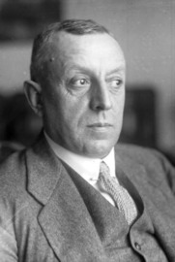
Fritz Thyssen
The Trading with the Enemy Act was enacted to prevent American businesses from aiding enemy nations during the war. After the war, Thyssen formed a multinational engineering corporation, Thyssenkrup that still operates to this day.

You can’t make this stuff up.
How this all passed mustard without any outcry from democrats, considering today's acidic political environment, so called anti-fascist democrats, is astounding.
Hey— what if the Democrats are really fascists and communists pretending to “make the world safe for democracy as they diligently work enslave humanity?” Well. That is EXACTLY what they are doing at the top, with their operatives and today's useful idiot Brown Shirts known as ANTIFA and BLACK LIVES MATTER.
The historical timeline proves this beyond a shadow of doubt.
The rabbit hole is deadly dark and deep, so I will try to give the Cliff notes version:
The quest for World Government began with Democrat President Woodrow Wilson, who was duped by his alter-ego Colonel Edward Mandel House, a Rothschild agent, to create the Federal Reserve.
The Federal Reserve is NOT Federal and there are no reserves. It is a private bank owned in part by— you guessed it ROCKEFELLER.
This is why the U.S. dollar is now worth only $ .05. It is also why two incomes at least are needed to own a home and feed a family of 4, when in the 1950’s one income could suffice— even if you were a simple store clerk.
How did this happen? The Federal Reserve.
The Federal Reserve has raped and pillaged America. It is why there is such a wide income gap and why poverty worsens and the middle class is vanishing. That is the plan. Deindustrialization via neo-feudalism. This especially notable in former Senator Prescott Bush's State of Connecticut, which now has the widest income gap in the U.S. followed by California and New York.
A great book to read on this subject is The Creature From Jekyll Island by G. Edward Griffin. An even more detailed account is Secrets of the Federal Reserve by Eustace Mullins.
Here is an except from pp. 34-36:
“For many years, there has been considerable mystery about who actually owns the stock of the Federal Reserve Banks. Congressman Wright Patman, leading critic of the System, tried to find out who the stockholders were. The stock in the original twelve regional Federal Reserve Banks was purchased by national banks in those twelve regions. Because the Federal Reserve Bank of New York was to set the interest rates and direct open market operations, thus controlling the daily supply and price of money throughout the United States, it is the stockholders of that bank who are the real directors of the entire system. For the first time, it can be revealed who those stockholders are.
This writer has the original organization certificates of the twelve FederalReserve Banks, giving the ownership of shares by the national banks in each district.
The Federal Reserve Bank of New York issued 203,053 shares, and, as filed with the Comptroller of the Currency May 19, 1914, the large New York City banks took more than half of the outstanding shares. The Rockefeller Kuhn, Loeb-controlled National City Bank took the largest number of shares of any bank, 30,000 shares. J.P. Morgan’s First National Bank took 15,000 shares. When these two banks merged in 1955, they owned in one block almost one fourth of the shares in the Federal Reserve Bank of New York, which controlled the entire system, and thus they could name Paul Volcker or anyone else they chose to be Chairman of the Federal Reserve Board of Governors. Chase National Bank took 6,000 shares.
The Marine Nation Bank of Buffalo, later known as Marine Midland, took 6,000 shares. This bank was owned by the Schoellkopf family, which controlled Niagara Power Company and other large interests. National Bank of Commerce of New York City took 21,000 shares. The shareholders of these banks which own the stock of the Federal Reserve Bank of New York are the people who have controlled our political and economic destinies since 1914. They are the Rothschilds, of Europe, Lazard Freres (Eugene Meyer), Kuhn Loeb Company, Warburg Company, Lehman Brothers, Goldman Sachs, the Rockefeller family, and the J.P. Morgan interests.
These interests have merged and consolidated in recent years, so that the control is much more concentrated. National Bank of Commerce is now Morgan Guaranty Trust Company. Lehman Brothers has merged with Kuhn, Loeb Company, First National Bank has merged with the National City Bank, and in the other eleven Federal Reserve Districts, these same shareholders indirectly own or control shares in those banks, with the other shares owned by the leading families in those areas who own or control the principal industries in these regions.
The "local" families set up regional councils, on orders from New York, of such groups as the Council on Foreign Relations, The Trilateral Commission, and other instruments of control devised by their masters. They finance and controlpolitical developments in their area, name candidates, and are seldom successfully opposed in their plans.
With the setting up of the twelve "financial districts" through the Federal Reserve Banks, the traditional division of the United States into the forty-eight states was overthrown, and we entered the era of "regionalism", or twelve regions which had no relation to the traditional state boundaries.
These developments following the passing of the Federal Reserve Act proved every one of the allegations Thomas Jefferson had made against a central bank in 1791: that the subscribers to the Federal Reserve Bank stock had formed a corporation, whose stock could be and was held by aliens; that this stock would be transmitted to a certain line of successors; that it would be placed beyond forfeiture and escheat; that they would receive a monopoly of banking, which was against the laws of monopoly; and that they now had the power to make laws, paramount to the laws of the states. No state legislature can countermand any of the laws laid down by the Federal Reserve Board of Governors for the benefit of their private stockholders. This board issues laws as to what the interest rate shall be, what the quantity of money shall be and what the price of money shall be. All of these powers abrogate the powers of the state legislatures and their responsibility to the citizens of those states.
The New York Times stated that the Federal Reserve Banks would be ready for business on August 1, 1914, but they actually began operations on November 16, 1914. At that time, their total assets were listed at $143,000,000, from the sale of shares in the Federal Reserve Banks to stockholders of the national banks which subscribed to it.
The actual part of this $143,000,000 which was paid in for these shares remains shrouded in mystery. Some historians believe that the shareholders only paid about half of the amount in cash; others believe that they paid in no cash at all, but merely sent in checks which they drew on the national banks which they owned. This seems most likely, that from the very outset, the Federal Reserve operations were "paper issued against paper", that bookkeeping entries comprised the only values which changed hands.
The men whom President Woodrow Wilson chose to make up the first Federal Reserve Board of Governors were men drawn from the banking group. He had been nominated for the Presidency by the Democratic Party, which had claimed to represent the "common man" against the "vested interests". According to Wilson himself, he was allowed to choose only one man for the Federal Reserve Board. The others were chosen by the New York bankers. Wilson’s choice was Thomas D. Jones, a trustee of Princeton and director of International Harvester and other corporations.
The other members were Adolph C. Miller, economist from Rockefeller’s University of Chicago and Morgan’s Harvard University, and also serving as Assistant Secretary of the Interior; Charles S. Hamlin, who had served previously as an Assistant Secretary to the Treasury for eight years; F.A. Delano, a Roosevelt relative, and railroad operator who took over a number of railroads for Kuhn, Loeb Company, W.P.G. Harding, President of the First National Bank of Atlanta; and Paul Warburg of Kuhn, Loeb Company. According to The Intimate Papers of Col. House, Warburg was appointed because "The President accepted (House’s) suggestion of Paul Warburg of NewYork because of his interest and experience in currency problems under both Republican and Democratic Administrations."27 Like Warburg, Delano had also been born outside the continental limits of the United States, although he was an American citizen. Delano’s father, Warren Delano, according to Dr. Josephson and other authorities, was active in Hong Kong in the Chinese opium trade, and Frederick Delano was born in Hong Kong in 1863.”
Starting to see the picture, the players and the scam everyone?
The timeline of events after the creation of the Federal Reserve initially was the funding of both sides of World War 1. After the war, President Wilson’s League of Nations failed namely because member states rightly felt their nations would lose too much sovereignty to Wilson’s 14 POINTS. Of course, the social engineers fixed that, didn’t they?
Rockefeller was a key player in Hitler’s rise to power, the creation of the medical mafia cartel, and the funding of the Kaiser Wilhelm Institute in 1922.
Watch the progression. See the patterns and the players. The playbook never changes.
First came the Great Depression caused directly by the Federal Reserve by restricting the money supply. Then came World War 2, the creation of the UN/NSA/CIA/State of Israel (Deep State).
Read THE FUTURE OF SOCIALISM, III, known as the “Schlesinger Manifesto” published in 1947 in the Partisan Review Vol. 14 No. 3.
Confessions of An Economic Hitman by John Perkins describes these alliances that have impoverished nations via socialism and debt. In 2014 I wrote an article titled, NATION KILLING: HOW THE NEW WORLD ORDER ROLLS explores this global neo-feudal operation by the IMF Bank to impoverish and enslave nations like Argentina and more recently, Venezuela. This is all part of the quiet war.
Assisted by the media and Hollywood Americans didn’t see this “quiet war” as it sought to create a global neo-feudal society that could be easily manipulated and controlled by the elite.
CIA coups and regime change operations in foreign countries since World War 2 to achieve this aim are as follows:
Iran: 1946
China: 1946-1949
(Chairman Mao went to Yale in 1920. Rockefeller funded Mao’s Great Leap Forward, the Cultural Revolution, and was the force behind opening the doors to China through his henchman Henry Kissinger, who also brokered the deal to for the US to import Arab oil in 1970’s leading to the Hegelian “Energy Crisis” and the stagflation of the 1970’s, Communist China partnered with ROUND TABLE GROUPS. In 2000, China’s addition to the World Trade Organization led to years of 10% annual GDP growth.)
Greece: 1947-1949
Italy: 1948
Philippines: 1948-1954
Korea: 1950-1953
Iran: 1953
Vietnam: 1954
Guatemala: 1954
Lebanon: 1958
Panama: 1958
Haiti: 1959
Congo: 1960
Vietnam: 1960-1964
Cuba: 1961-1962
Laos: 1962
Ecuador: 1963
Panama: 1964
Brazil: 1964
Vietnam: 1965-1975
Indonesia: 1965
Congo: 1965
Dominican Republic: 1965
Laos: 1965-1973
Ghana: 1966
Guatemala: 1966-1967
Cambodia: 1969-1975
Oman: 1970
Bangladesh 1971
Laos: 1971-1973
Chile: 1973
Cambodia: 1975
Angola: 1976-1992
Iran: 1980
Libya: 1981
El Salvador: 1981-1992
Nicaragua: 1981-1990
Lebanon: 1982-1984
Grenada: 1983
Honduras: 1983-1989
Iran: 1984
Libya: 1986
Bolivia: 1986
Iran: 1987-1988
Libya: 1989
Philippines: 1989
Panama: 1989-1990
Liberia: 1990
Iraq: 1990-2003
Haiti: 1991
Somalia: 1992-1994
Yugoslavia: 1992-1994
Bosnia: 1993-1995
Haiti: 1994-1996
Croatia: 1995
Zaire (Congo): 1996-1997
Liberia: 1997
Sudan: 1998
Afghanistan: 1998
Yugoslavia: 1999
Macedonia: 2001
Afghanistan: 2001-2021
Venezuela: 2002
Iraq: 2003-present
Haiti: 2004
Ukraine: 2004, 2013-2014 to present
Palestine: 2006-Present
Yemen: 2009-present
Syria: 2005-2009, 2011-present
Libya: 2011
Venezuela: 2025-26
Years before Skull and Bones President H.W. Bush infamously called for a “New World Order” on September 11, 1990, and 11 years before the 9/11/01 Terror Attacks, President Nixon called for a New World Order and a "generation of peace," on his trip to China in 1971.
On August 10, 1973 David Rockefeller wrote an OP ED article published in the New York Times titled, A CHINA TRAVELER, where Rockefeller called Chairman Mao “one of the greatest leaders in history.” Mao murdered more than 60 million of his own people.
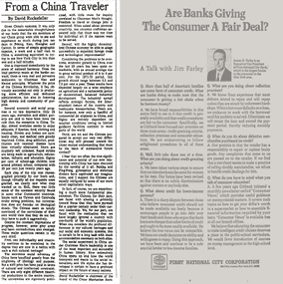

Sounds quite peaceful doesn't it?
These are the types of leaders favored by the Malthusian global elite and selected to the hierarchy of the Democrat Party, make no mistake about it. History proves the ROUND TABLE GROUO love to prop up corrupt dictators and tyrants. They are hardcore totalitarians operating by the Satanic Law of Reversal: Peace means War. Justice means tyranny.
In fact, since its inception, the United Nations has spoken relentlessly about peace but achieved nothing but war, pestilence and death.
See how all this works?
Speaking of the United Nations, the UN building stands on land donated by JOHN D. ROCKEFELLER.
Are you starting to see a pattern here?
If you think the Rockefellers and Bill Gates, who modeled his foundation after the Rockefeller Foundation, are altruistic philanthropists you seriously need to WAKE UP and study the history of the ROCKEFELLERS. Namely, the history of American education since 1903, the creation of the Federal Reserve and the Petrochemical Pharmaceutical Investment Business, also known as the Big Pharma allopathic Medical Mafia cartel, who continue to wage war on homeopathic medicine and natural remedies and cures.
In 1910 Carnegie Endowment funded the FLEXNER REPORT, to demonize natural cures, calling all treatments “quackery”. This led to the closure of all homeopathic hospitals in the United States and Canada replaced by allopathic medicine and soon became the global norm. Natural remedies and cures were a direct threat to Rockefeller’s medical mafia because natural cures were not able to be patented for profit.
Read: Rockefeller Medicine Men - Medicine and Capitalism in America by E. Richard Brown for more clarity on the Medical Mafia poisoning America..
The Truth About Rockefeller Public Enemy No. 1
The Rockefeller File by Gary Allen
Foundations of the American Century The Ford, Carnegie & Rockefeller Foundations in the Rise of American Power Inderjeet Parmar
The Rockefeller Foundation White Paper (Covid-19) 4-22-2020
David Rockefeller - Memoirs (2003, Random House)
The Bilderberg Group was founded in 1954 tasked to consolidate the resources of the world and to incrementally de-industrialize and depopulate the planet to 500,000,000.
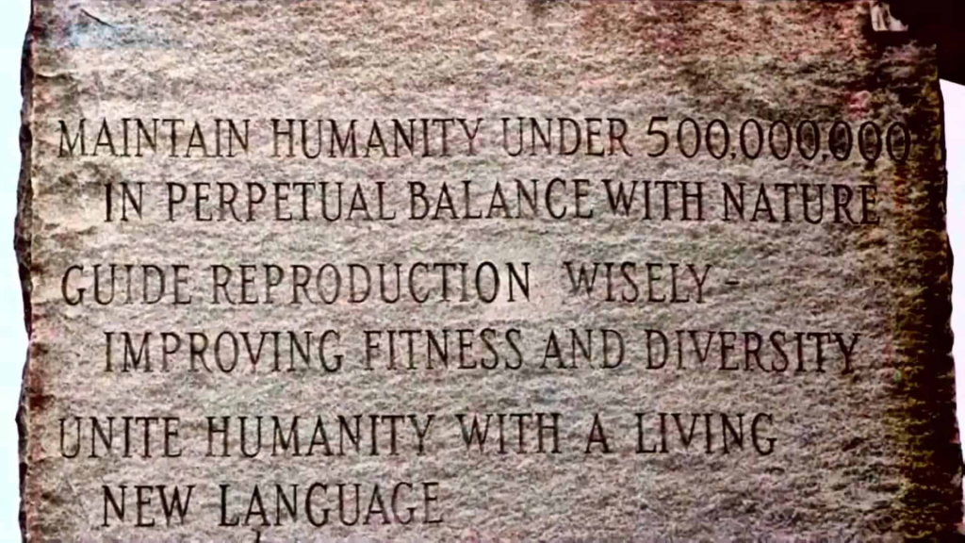
This “New Age” of Reason was written in stone in 1980 on the Georgia Guidestones.

The Guidestones were destroyed, blown to bits in my view, by the Hand of God on July 6, 2022.
THE EUROPEAN UNION WAS FOUNDED BY FORMER NAZIS AND NAZI SYMPTHIZERS
The Treaty of Rome brought about the creation of the European Economic Community (EEC). The treaty was signed on March 25, 1957 by Belgium, France, Italy, Luxembourg, the Netherlands and West Germany. The EEC is now titled the Treaty on the Functioning of the European Union.
The 1992 UN Rio Earth Summit set the stage for the creation of the one world government, using bogus pseudo science: climate change, a ruse cooked up by the Club of Rome in 1968 to induce the nations of the world to live “sustainably” (sound familar?) and to wifully deindustrialize to “save the planet”.
To commence this endless gaslighting propaganda campaign, in 1972 the Club of Rome published Limits To Growth, a phony overpopulation narrative propped up the media and predictive programming from Hollywood ever since.
Movies like SOYLENT GREEN, LOGAN’S RUN and others pushed the overpopulation theme nonstop to bang it into the heads of the masses. So did television. Still, to this day not one of the wild and crazy fear mongering theories in the book have come to pass. In fact, the WWF’s polar bear running out of ice was a lie. The polar icecaps aren’t melting they are expanding. Still, the devious spin doctors try to explain away these lies by stating more of them. But alas, this is how social engineering works.
In 1992 the Club of Rome published THE FIRST GLOBAL REVOLUTION written by Alexander King and Bertrand Schneider. When reading the book and comparing it to history and the use of the Satanic Law of Reversal, you can see that the exact opposite goals are being executed in real time.
The First Global Revolution is a 1991 report by the Club of Rome, co-authored by Alexander King and Bertrand Schneider, that argues humanity is experiencing a "first global revolution" of interconnected social, economic, and environmental crises. It calls for a shift from a military to a civil economy, addressing global poverty, climate change (carbon emissions, reforestation), and energy conservation as a blueprint for the 21st century to ensure world survival.
Key themes and arguments
- A new era of global challenges: The book posits that humanity has entered a new phase where global problems like poverty, environmental degradation, and conflict are intertwined and require a unified, global response.
- Military to civil economy: A central proposal is the conversion of resources from military spending to civil needs, such as poverty reduction and environmental protection.
- Environmental security: It emphasizes the need to tackle global warming by reducing carbon dioxide emissions, promoting reforestation, and developing alternative energy sources.
- North-South divide: The report addresses the disparities between the developed and developing world, highlighting the negative impacts of exploitation.
- A blueprint for the future: Published as a follow-up to The Limits to Growth, it serves as a strategic guide for governments and the world to navigate the challenges of the coming century.
On page 75, the true reasoning behind the climate change hoax is exposed. Massive global depopulation is the goal, noting that the enemy of humanity is mankind itself.

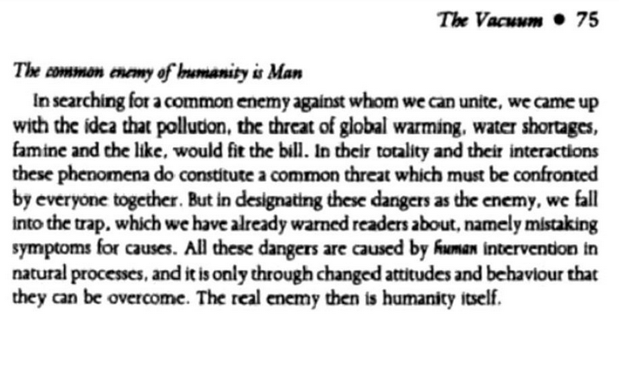

These documents and the Rio Summit are the foundations of what became United Nations AGENDA 21
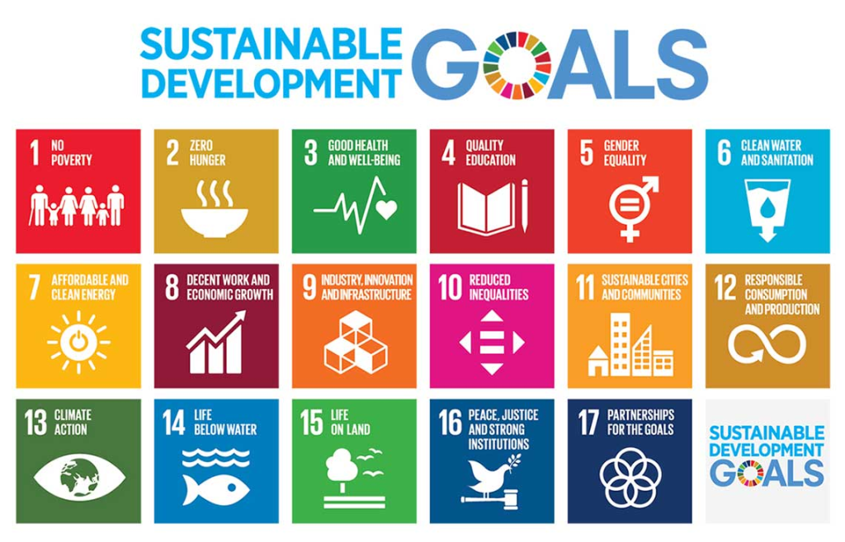
The Maastricht Treaty came into effect on November 1, 1993, formally establishing the European Union (EU). The treaty, fully in line with UN depopulation agenda and the one world government, one world currency agenda was drafted in 1991 by delegates from the European Community at a meeting in Maastricht in the Netherlands.
The agreement called for open borders in Europe, a strengthened European parliament, the creation of a central European bank, and common security policies. The treaty also established a single European currency, the “euro.”
What we know as the today’s European Union came into existence with the Treaty of Rome. The progeny of the former Nazis and Nazi collaborators who birthed the Treaty of Rome are today the leaders at the EU. https://global-politics.eu/the-eus-architects-nazis-and-nazi-collaborators/
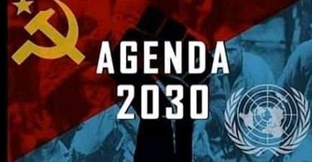
Starting to all make sense, now?
TO GRASP A GREATER UNDERSTANDING, YOU MUST READ THE 1979 DOCUMENT SILENT WEAPONS FOR QUIET WARS. This secret document uncovered in 1986, was handed out to 15 select members of the Bilderberg Group at their 1979 meeting in Baden, Austria. Every page has come to pass in the real world, or is poised to do so.
A massive Malthusian treatise that is directly involved in the "Quiet War" is the book ECOSCIENCE, co-penned by Obama's "Science Czar" John P. Holdren and published in 1977.
THE DEMOCRATS HYPOCRISY IS PURPOSEFUL
While democrat leaders like Nancy Pelosi got her hair done and her nephew Gavin Newsom dined at the high end French Laundry during lock down, their constituents suffered under authoritarian COVID protocols and lock down. Incredibly, there was little if any outcry from the Democrat’s sycophant constituents— who complied so well, many have been left permanently scarred, brainwashed beyond help, still wearing masks to go into stores to this day— Even in the heat of July.
This powerful piece of psychological warfare stoked the growing insanity we see today coming from the useful idiot left.
Masks do nothing to stop transmission of COVID, just like the deadly COVID shots themselves. FACT! YOU WERE LIED TO! YOU WERE GASLIT! And the gaslighting feverishly continues.
After all, we are dealing with Democrat voters, who long ago drank the commie Kool Aid, not realizing that the compliance of their constituents, only proved to Democrat leaders that their flock are indeed useful idiots, who can be easily rallied and manipulated to act and react like trained dogs on command. We see this clearly in the sickening insanity currently unfolding in Minnesota.
The fact is, most Americans have not forgotten the suffering endured by people living in Democrat states during COVID. Especially those who lost loved ones who died alone, due to the evil, totalitarian COVID protocols that we have now learned were all literally fabricated.
How can anyone forget, or forgive the many tyrannical crimes against humanity forced on society by the UN World Health Organization and leftist governments across the world? Democrat politicians jetted to Florida and other republican states that had no MANDATES to avoid the totalitarianism they cast over their constituents in every blue state and city in America.
While Amazon and big global box stores prospered, labeled as “essential businesses,” small local business were forced to closed. Many never reopened. Every protocol was designed to kill people and shutter businesses.
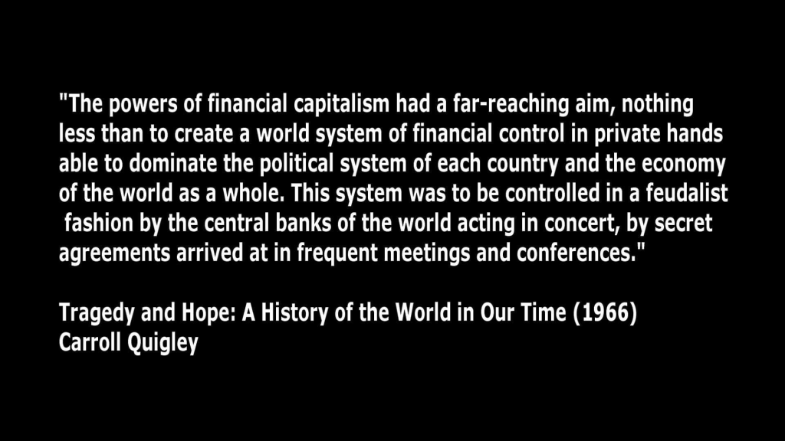
https://www.statista.com/topics/7702/coronavirus-impact-on-small-business-in-the-us/#topicOverview
Businesses that defied the COVID mandates were fined and owners arrested. It was an incredible transfer of wealth to the elite class, based on an incredibly BIG LIE. Countless Americans lost their jobs for not complying with the ILLEGAL totalitarian fascist COVID orders forced upon them by DEMOCRAT TRAITORS. Churches were closed, but liquor stores and strip clubs were allowed to operate. They were “essential”. Sounds very Satanic, doesn’t it. Well, it was . . .
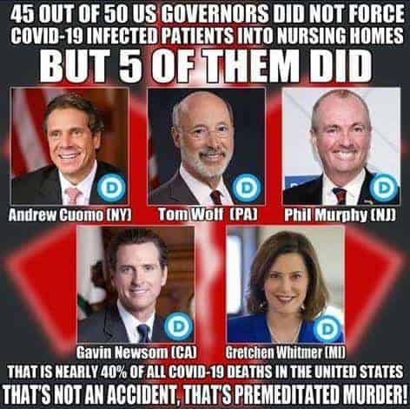
Even worse and more revealing, COVID patients were sent into nursing homes in 5 democrat states to deliberately kill elderly residents and reduce Medicaid rolls in their states.
As we can now see, with the despicable Democrats attempts to foment a civil war to distract from the billions of dollars of Democrat fraud recently exposed in Minnesota. More and more each day, the dirty Democrats show their Satanic stripes, as they did during COVID.
Have you forgotten?
In Democrat run cities and states those who didn’t comply with COVID mandates were fined and arrested. Have you forgotten the controlled mainstream media’s 24/7 fear porn propped up by Democrats for 2 years to keep the lock downs going while castigating anyone who defied the BIG LIE? Effective treatments like Ivermectin were banned.
Doctor's licenses were threatened for not complying with the World Health Organization’s deadly treatments. Others were jailed for healing patients with what the media dubbed “horse paste”. And all of this— all of it was was supported and propped up by the Democrat’s partners in crime, the corporate media. It was and is, SO obvious.
The fact is, almost every COVID death occurred in a hospital. Most patients died of kidney and respiratory failure due to the deadly use of Remdesivir and ventilators, not COVID. These in hospital protocols were designed to kill, and they did.
Americans in blue states and cities lost their jobs if they didn’t mask up and take the deadly COVID shots. I myself lost my job for refusing to wear a mask here in Connecticut. It was all part of the de-industrialization/depopulation plan.
Still, no one has gone to prison for these massive crimes against humanity. Not Fauci, Peter Daszak, the 5 Democrat governors, or any of the Deep State criminals who lied, swindled and continue to lie and swindle the American people. This must end now!
The truth is out. The emperor has no clothes. Know the enemy.
The massive psychological warfare operation against the American people and the people of the world during COVID created mass formation psychosis, this combined with continuous media and Democrat agitation has caused emotional destruction in their lunatic fringe base and have led us to where we are today.
This is a direct result of Obama's amending the Smith-Mundt Act which amended the 1948 bill . The act was signed with the amendment along with National Defense Authorization Act for fiscal year 2012.
The Smith-Mundt act regulated what the State Department was allowed to broadcast to foreign audiences, and also banned the dissemination of content produced by them on domestic soil.
Obama's actions paved the way for the censorship we now see due to "disinformation" or "hate speech". This led to social media account shut downs for speaking out against the lock downs and deadly injections, paving the way for the totalitarian advance of OPERATION LOCKSTEP. It is a direct reason America is where it is today in so far as the media and Democrat politicians blatantly lying to American people.
THE GASLIGHTING CONTINUES
The insurrectionists in Minnesota who are attacking ICE agents attempting to execute LEGAL DEPORTATION COURT ORDERS on illegal alien drug dealers, human traffickers, murderers, rapists and pedophiles serves to illustrate the level of insanity the DNC have whipped their base up to with their verbatim talking points. The DNC voter fraud is out of contril. Their dead voter rolls have been exposed. The reason the Democrats are so rabid, is because without these dead voters and voters who moved out of state, Democrats will never have the numbers they need to win elections.
Here in Connecticut, governor Ned Lamont refuses to release the state's voter rolls to the Trump Administration, implying massive voter fraud exists here. Of course it does. There is massive voter fraud in Connecticut.
Democrats even commit fraud against each other, since they had packed the ballot box for decades. A case point: Bridgeport is notorious for voter fraud. So much so, that Bridgeport mayor Joe Ganim stole $700,000 from the city and went to prison. Good, right? Well, when Ganim got out of prison he ran for re-election as mayor-- and won.
I don't know about you, whether democrat, independent or republican, would you vote for someone convicted of fraud to the tune of $700,000? Probably not, which indicates there are devious forces behind the scenes diligently working to keep Democrats in power in Connecticut for decades, despite dismal economic realities. Removing dead voters and people who moved out of state from voter rolls would be catastrophic for Connecticut Democrats.
Removing illegal aliens and dead voters is a direct threat to the Democrat's Deep State criminal enterprises that has now been fully exposed nationwide. NGO's like Catholic Charities assisted in the import of millions of illegal aliens under the Biden junta. These are facts.
While Democrats currently focus on the low volume cases of American citizens accidentally detained by ICE while detaining dangerous illegals, they ignore the cold hard fact that extremely dangerous illegal aliens are the bulk of the detainees.
Sadly, these leftists are too demented, mentally ill to grasps this reality. It does not compute. These poor souls are “contaminated,” ideologically subverted to the max, actually believing things like two men can birth a baby.
The Deep State's psyop narrative pushed by the Democrats now includes leftist physicians— and even a US Supreme Court judge who cannot define what a woman is. Sick.
Yes, Democrats have been successfully brainwashed. Former KGB propagandist Yuri Bezmenov explains in a 1984 interview with G. Edward Griffin:
https://www.howardnema.com/wp-content/uploads/2021/03/FULL-INTERVIEW-with-Yuri-Bezmenov-The-Four-Stages-of-Ideological-Subversion-1984.mp4
The audacity of the despotic Democrats and their ever failing yet continuous attempts to gaslight the public via their brainwashed lunatic fringe base, whipping them into a frenzy by relentlessly calling republican politicians and conservatives constituents “fascists” and “racists.”
Funny how they call them fascists, but never call them communists, isn’t it? As if communism didn’t kill more than 100,000,000 in the last century. The cognitive dissonance is baffling.
Related: COGNITIVE WARFARE
This is not only appalling it is ironic. After all, the tyrannical crimes committed by the despotic Democracts during the COVID scam is rich.— As rich as the Democrats and their operatives became after stealing billions of COVID relief bucks in Minnesota and undoubtedly every other democrat state. The CBO estimates more than $300 billion dollars of fraud occurs every year.
While Democrats call for "sustainability" this fraud that they and their partners in crime profit from is unsustainable.
When will there be justice?


Sources/Related:
Agenda 2030
All Wars Are Bankers Wars
Brainwashed: A New History of Thought Control by Daniel Pick
Brainwashing
Compromised: Clinton, Bush and the CIA by Terry Reed and John Cummings
Covert Operations of the U.S. National Security Agency
Dark Alliance – The CIA, The CONTRAS AND THE CRACK COCAINE EXPLOSION by Gary Webb
Dark Alliance (articles) by Gary Webb
Death by Deception: Advanced Improvised Booby Traps by Jo-Jo-Gonzales
Death by Government by R.J. Rummel (1994)
The Death of Larry P. Mc Donald
DEPOPULATION AS A POLICY CHALLENGE IN THE CONTEXT OF GLOBAL DEMOGRAPHIC TRENDS by Wolfgang Lutz and Nicholas Gailey UNFPA White Paper (October, 2020)
Devil's game: How the United States helped unleash Fundamentalist Islam by Robert Dreyfuss
Drugs As Weapons Against Us by John L. Potash
Education and the Social Order by Bertrand Russell
Education in the New Age by Alice Bailey
Eugenics and the Development of U.S. Food and Drug Law
Federal Failure: The Miseducation of America's Children
Fleshing Out Skull and Bones (2003)
Foundations of the American Century Ford, Carnegie and Rockefeller Foundations and the Rise of American Power by Inderjeet Parmar
Grace Commission Report (1984)
History's Greatest Heist The Looting of Russia by the Bolsheviks by Sean McMeekin
Inside the Company by Philip Agee
Jews and Freemasons in Europe 1723-1939 by Jacob Katz
Kabbalah Secrets Christians Need to Know by Deanne Loper
Kabbalah-Unveiled
Kill The Messenger
Lenin: His life and legacy
Liberalism is a Mental Disorder by Michael Savage (2005)
Limits to Growth
Maos Crusade Politics and Policy Implementation in China’s Great Leap Forward by Alfred L. Chan
Memoirs by David Rockefeller (2003)
Mental Illness and the Left
Mindwar by Col. Michael Aquino (1980)
Morals And Dogma by General Albert Pike (1871)
Murder At The Vatican The Bolshevik Pontiff
Mystery Babylon Series Complete – William Cooper
National Security Memorandum 200 (1974)
New England and the Bavarian Illuminati by Vernon Stauffer (1918)
Nihilism -The Root of the Revolution of the Modern Age (Fr Seraphim Rose)
None Dare Call it A Conspiracy (1971) by Gary Allen
Operation Northwoods
Operation Paperclip by Annie Jacobsen
Pharmakeia: Sorcery, Witchcraft, Pharmaceutical, Pharmacy, Pharmacist & the Roots of Modern Day Drug Industry by Dr. Scott Johnson
Physical Control of the Mind Toward a Psychocivilized society (1969) by Jose Delgado
Proofs Of A Conspiracy by John_Robison (1798)
Psychological Operations Tactics, Techniques, and Procedures (2003)
Radicals, Resistance, and Revenge: The Left’s Plot to Remake America (2019)
Rise of the New World Order: The Culling of Man (2013) by J. Micha-el Thomas Hays
Ritual Offerings by Aaron Leitch
Rules for Radicals by Saul Alinksy
Satanic Crime – A Threat in the New Millennium
Secret Societies and Psychological Warfare by Michael A. Hoffmann II
Secrets of the Federal Reserve by Eustace Mullins
Secret Practices And Teachings of Sufi Freemasons
Secrets and Lies: A History of CIA Mind Control and Germ Warfare by Gordon Thomas
Senate Investigating Committee On Education California Textbooks (1948)
Socialism An Economic and Sociological Analysis by Ludwig Von Mises
STATE-CONDUCTED POLITICAL VIOLENCE: A PERSISTENT JURIDICO-POLITICAL
PHENOMENON (EVEN IN TIMES OF TRANSFORMATION)
State Secrecy
Study: 450,000 Americans Die Every Year: Medical Mistakes #3 Cause of Death in US
Tax Exempt Foundations and their Influence Within Society by Ryan Kapchinsky
Ten Myths About Israel by Ilan Pappe (2017)
The 1948 Ethnic Cleansing of Palestine
The Age of Intelligent Machines (1990)
The Age of Spiritual Machines (1999)
The Anglo-American Establishment by Carroll Quigley
The Atlantean Conspiracy by Eric Dubay
The Aquarian Conspiracy by Marilyn Ferguson
The Best Enemy Money Can Buy by Antony C. Sutton
The Bilderberg Conferences as Transnational Informal Governance Network by Aleksander Miłosz Zieliński
The Birth of the Propaganda State: Soviet Methods of Mass Mobilization, 1917-1929 by Peter Kenez (1985)
The Conquest Of Happiness by Bertrand Russell
The Council on Foreign Relations: A Case Study in the Societal Bases of Foreign Policy Formation
The Creature From Jekyll Island by G. Edward Griffin
The Crescent and the Compass by Angel Millar
The Dark Brotherhood by Dr. Stanley Monteith
The Dark Brotherhood lecture by Dr. Stanley Monteith
The Deliberate Dumbing Down Of America by Charlotte Iserbyt
THE DOCTRINE OF FASCISM by Benito Mussolini and Giovanni Gentile
The End of America by Naomi Wolf
The Evolution Of Civilizations â€“ An Introduction To Historical Analysis -1st & 2nd Editions by Carroll Quigley
The First Global Revolution: A Report by the Council of the Club of Rome by Alexander King and Bertrand Schneider
The Fluoride Deception by Christopher Bryson
The Forbidden Knowledge of Secret Societies by Philip Gardiner
ThThe Great Reset by Klaus Schwab
The Great Reset and the War for the World by Alex Jones
The Great Awakening by Alex Jones
The Hidden Dangers of the Rainbow by Constance Cumbey
The Hidden History of Money and Feudal Order Usury Secrets
The History of Modern Warfare
The Fourth Industrial Revolution by Klaus Schwab
The Invisible Government by David Wise and Thomas Ross
The Irregulars: Roald Dahl and the British Spy Ring in Wartime Washington by Jennet Conant (2009)
The killing of Uncle Sam: The Demise of the United States of America by Paul Williams
The Kinsey Reports 1948 & 1953 To Today Fraudulent Science Based Legal Reform Eliminates Protections For Women And Children In All US State Criminal Codes by Judith Reisman Ph.D.
The Order of Skull and Bones by Antony Sutton
The Population Bomb

